Requirement Analysis

Data Flow Diagram & User Stories

|  |  |
| --- | --- |
| Date | 19 June 2025 |
| Team ID | LTVIP2025TMID51764 |
| Project Name | ShopSmart: Your Digital Grocery Store  Experience |

Data Flow Diagram (DFD) :

A Data Flow Diagram (DFD) is a graphical representation of how data moves through a system. It shows the flow of data between processes, external entities, and data stores in a system without showing program logic or internal data structures.

Why Use a DFD?

* It provides a clear overview of how the system handles data.
* Useful for analyzing and designing the system architecture.
* Helps identify inputs, outputs, processes, and data storage in a system.

Components in a DFD

* External Entities: Represent users or systems that interact with the application.
* Processes: Represent tasks/functions performed by the system.
* Data Stores: Databases or storage that hold data.
* Data Flows: Arrows that show the movement of data between entities, processes, and stores.

Example (Simplified Flow for ShopSmart):

Customer --> [Login/Register] --> [Authentication Process] --> [User Database]

Customer --> [Browse Products] --> [Product Search Process] --> [Product Database]

Customer --> [Add to Cart] --> [Cart Process] --> [Cart Database]

Customer --> [Checkout] --> [Order Process] --> [Order Database]

Admin --> [Manage Products] --> [Product Management Process] --> [Product Database] Data Flow Diagram (DFD):

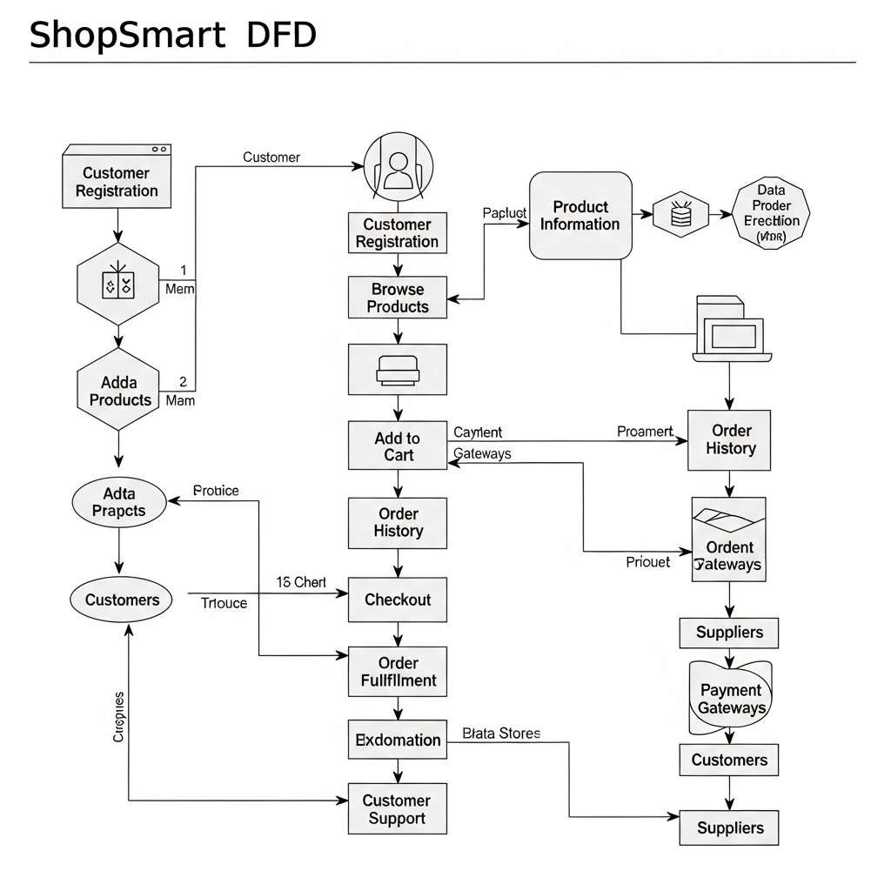

User Stories Table:

|  |  |  |  |  |  |  |
| --- | --- | --- | --- | --- | --- | --- |
| User Type | Functional  Requirement (Epic) | User  Story  Number | User Story / Task | Acceptance Criteria | Priority | Release |
| Customer  (Mobile user) | Registration | USN-1 | As a user, I can  register for the application by entering my  email, password, and confirming my password. | I can access my account / dashboard | High | Sprint1 |
|  |  | USN-2 | As a user, I will receive a  confirmation  email once I have registered for the application. | I can receive a confirmation  email & click confirm | High | Sprint1 |
|  |  | USN-3 | As a user, I can  register for the application through  Facebook. | I can register & access the  dashboard via  Facebook | Low | Sprint2 |
|  |  | USN-4 | As a user, I can  register for the application through Gmail. | I can register & access via Gmail | Medium | Sprint1 |
|  | Login | USN-5 | As a user, I can log into the  application by  entering my email & password. | I can access the system securely | High | Sprint1 |
| Customer (Web user) | Product Search & Order | USN-6 | As a user, I can browse and search products using  category and price filters. | I can view filtered product results | High | Sprint2 |
|  |  | USN-7 | As a user, I can add products to  my cart and adjust quantities. | My cart updates dynamically | High | Sprint2 |
|  |  | USN-8 | As a user, I can place orders with a selected payment method. | I get a success message and  confirmation email | High | Sprint2 |
| User Type | Functional  Requirement (Epic) | User  Story  Number | User Story / Task | Acceptance Criteria | Priority | Release |
| Seller | Product  Management | USN-9 | As a seller, I can log in to my  dashboard and manage my product listings. | I can add/edit/delete products | High | Sprint3 |
|  |  | USN-10 | As a seller, I can view and track customer orders. | I see a list of customer orders | Medium | Sprint3 |
| Admin | Admin Dashboard | USN-11 | As an admin, I can approve or deactivate sellers. | I can manage seller status from dashboard | High | Sprint3 |
|  |  | USN-12 | As an admin, I can manage  product listings and user accounts. | I can add/edit/delete  any products or users | High | Sprint3 |